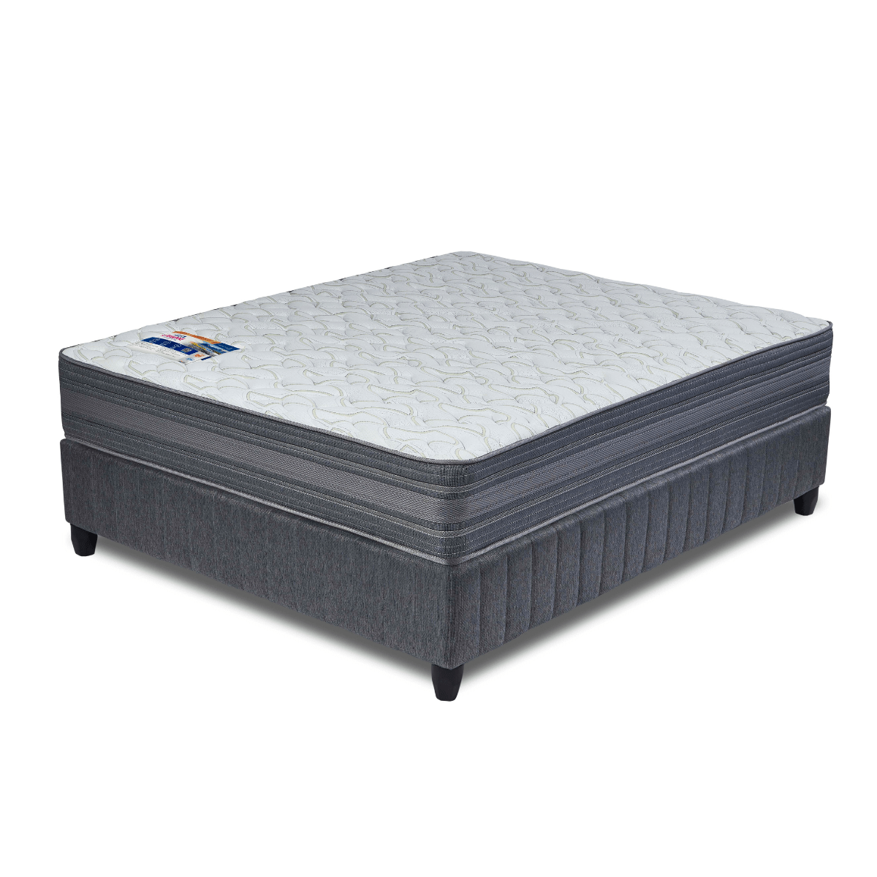


Model : Weightmaster Base Set
Supplier/Manufacturer : Rest Assured
Range : Heritage Bonnel Coil Collection
Prices – Bed Set :
- Single Bed Set – R9059
- Three Quarter Bed Set – Not Available
- Double Bed Set – R12209
- Queen Bed Set – R13449
- King Bed Set – R16599
Prices – Mattress Only :
- Single Mattress Only – R7409
- Three Quarter Mattress Only – Not Available
- Double Mattress Only – R10179
- Queen Mattress Only – R11359
- King Mattress Only – R13289
Prices - Extra Length Bed Set :
- Single Extra Length Bed Set – R9789
- Three Quarter Extra Length Bed Set – Not Available
- Double Extra Length Bed Set – R13189
- Queen Extra Length Bed Set – R14529
- King Extra Length Bed Set – R17929
Prices - Extra Length Mattress Only :
- Single Extra Length Mattress Only – R8009
- Three Quarter Extra Length Mattress Only – Not Available
- Double Extra Length Mattress Only – R10999
- Queen Extra Length Mattress Only – R12269
- King Extra Length Mattress Only – R14359

*Please use this link for guideline for creating the page* - https://www.bedsonline.co.za/product/rest-assured-weightmaster-queen/
Rest Assured Link - https://restassured.co.za/our-ranges/heritage/weightmaster/

